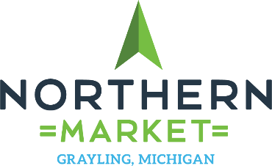

September 26, 2018

To Whom it May Concern:
The City of Grayling is applying for a grant from the Michigan Economic Development Corporation (MEDC) for the construction of the Northern Market and Food Hub.
The funding from the MEDC grant is fundamental to the commencement of the Northern Market/Food Hub project. The foundation of the entire project, one that will encourage growth and sustainability for years to come, begins with having a solid infrastructure.
With the fresh functional design of the Northern Market, it will be able to accommodate and fulfill the needs of the ever-changing food industry. Not only will the Northern Market/Food Hub promote Grayling as a community, it will also assist the food producers throughout Michigan to expand beyond their current markets.
The Farm-To-Fork and the Farm-To-School movements have had a powerful impact on the way consumers view and buy their produce. Restaurants and schools are now encouraged to work with producers closer to home. The only problem is that while some areas have a vast choice of produce, other areas are quite limited.
The Northern Market/Food Hub is in a centralized location that allows producers to get their product across Michigan and available to more communities. The relationships between farmers, schools, restaurants, and other food service providers will only strengthen Michigan as a whole by keeping revenue circulating throughout our state.
Educational resources are also available to food service related professionals throughout Michigan. The NMFH is committed to making the Michigan food industry an exceptional experience for everyone.
A letter of support from your organization would make a large impact to the success of our efforts.
We look forward to speaking with you in regards to how the Northern Market/Food Hub can be of assistance to your organization. Please feel free to reach out to our team with any questions.

Sincerely,

The Northern Market Team
PO Box 549 Grayling, MI 49738
northernmarket@cityofgrayling.org
(989) 348-2131

